OFFICIAL COORDINATION REQUEST FOR NON-ROUTINE OPERATIONS AND MAINTENANCE

COORDINATION TITLE- 14TDA04 EFL AWS excavation
COORDINATION DATE- April 22, 2014
PROJECT- The Dalles Lock and Dam
RESPONSE DATE- 8 May 2014 (FPOM meeting).

Description of the problem- Preparation for construction of the East Fishladder Auxiliary Water Supply backup system requires sub-grade exploration in the location of the proposed pipe. Two exploration pits will be dug for this exploration.

In order to provide accurate geotechnical design parameters for the accommodation of the updates to be constructed, subsurface exploration by use of test pits and attempted mechanical rock removal will be required, as well as vibration monitoring and a plate load test. Information will be evaluated and compiled for producing a Geotechnical Data Report for the site which will be for the use of the design team and for purpose of future record.

The point of the exploration is to discover and verify what we already know about the underlying material: It is likely rock fill on top of basalt (lava flow rock) that is 8-12 feet below the surface. Next, we will attach a hydraulic hammer to the machine and attempt to pick away at the basalt using a method likely to be attempted by our future contractor. We do not expect that this will be possible as original construction indicates that this material is extremely strong.

Digging 8-12 feet with an excavator will take about 10-15 minutes. Attaching the hammer will take another 2-3 minutes, and we will attempt to break up the rock that will likely take 5-10 minutes, possibly more or less. This duration depends on what we find. (Again, it's an exploration...) We'll backfill with the same material that was in the hole (about 3 minutes), then repave the location.

The second location will have a plate load test on the fill material performed instead of attempting to break up rock located deeper. The plate load test pushes a small plate to create correlations of pressure over area so that readings about bearing capacity and settlement of the material can be obtained for foundation analysis and design. This can take some time to set up and perform, but it doesn't involve any "big" machinery. The purpose of the exploration is to determine the subsurface conditions and geotechnical parameters for foundation and grading design. Foundations are anticipated to accommodate a new 10-foot diameter water pipe located up to 15 feet below existing grades. The exploration program will include the use of two test pits utilizing a very large excavator, collection of soil and rock samples for observation and possible future laboratory testing, determination of ground water depths, if ground water is encountered, and attempted mechanical rock removal. Vibration recording equipment will be used to monitor the work and may be used as reference for this and other projects that may impact fish. According to as-built drawings, this area should reveal subsurface soils containing a rock fill underlain by solid basaltic flows.

Both test pit locations will be within the 50’ construction activity boundary identified in the Fish Passage Plan for work conducted during fish passage season (March 1 – November 30). The first pit will occur near the junction pool of the East Fishway and Fish Ladder structure. The second pit will occur about 40’ vertically from the bottom of the upper fishladder structure. This work must be performed as soon as possible in order to provide critical design information to the design team for the Plans and Specifications phase of the project.

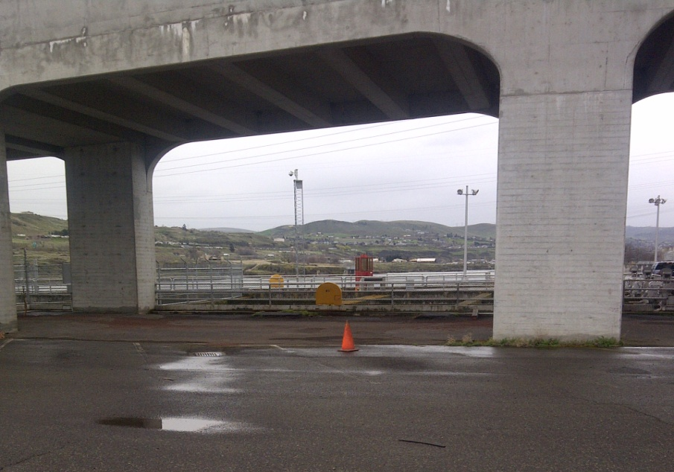
One pit will occur where the traffic cone is located in picture. Junction pool is immediately below the yellow box, approximately 40’ distance from work location.

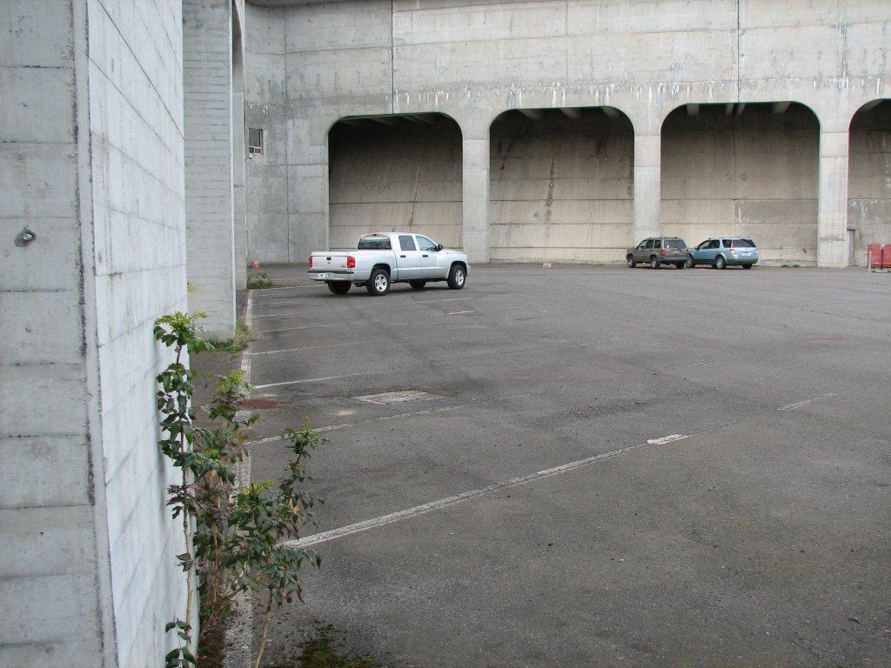

The second pit will occur near the location of the 2 SUVs in the above picture, approximately 40’ vertical from the base of the fish ladder structure.

Vibration will be monitored to determine frequency levels at junction pool and surrounding structures in order to provide data related to construction in the area.

Type of outage required- No outage necessary.

Impact on facility operation- None

Length of time for work- 2 to 4 days. Targeting late May.

Duration of impacts- 30 – 60 minutes.
Digging 8-12 feet with a machine like this will take about 10-15 minutes. Attaching the hammer will take another 2-3 minutes, and we will attempt to break up the rock that will likely take 5-10 minutes, possibly more or less. This duration depends on what we find. (Again, it's an exploration...) We'll backfill with the same material that was in the hole (about 3 minutes), then repave the location.

The second location will have a plate load test on the fill material performed instead of attempting to break up rock located deeper. The plate load test pushes a small plate to create correlations of pressure over area so that readings about bearing capacity and settlement of the material can be obtained for foundation analysis and design. This can take some time to set up and perform, but it doesn't involve any "big" machinery.

Expected impacts on fish passage-
Downstream migrants- None expected due to adequate distance from all juvenile passage routes.

Upstream migrants- This work will occur within the 50’ buffer required by the FPP.

The passage numbers for the proposed timeframe are shown in the table below.

Table 1. Fish counts at TDA from 1-31 May 2009 - 2013.
DATE | Total fish | Chinook (all) | Steelhead  Total | Steelhead  (clipped) | Steelhead  (unclipped)
1 May | 3519 | 3511 | 8 | 5 | 3
2 May | 3596 | 3584 | 12 | 7 | 5
3 May | 4422 | 4409 | 13 | 7 | 6
4 May | 5235 | 5226 | 9 | 4 | 5
5 May | 5963 | 5953 | 10 | 6 | 4
6 May | 3553 | 3545 | 9 | 5 | 3
7 May | 4560 | 4549 | 11 | 9 | 2
8 May | 6542 | 6532 | 10 | 8 | 2
9 May | 5535 | 5519 | 15 | 8 | 7
10 May | 6797 | 6789 | 8 | 5 | 3
11 May | 7624 | 7612 | 13 | 8 | 5
12 May | 6870 | 6861 | 9 | 5 | 3
13 May | 4421 | 4410 | 11 | 8 | 2
14 May | 4857 | 4849 | 8 | 7 | 1
15 May | 4945 | 4932 | 13 | 8 | 4
16 May | 4384 | 4371 | 12 | 11 | 2
17 May | 4333 | 4315 | 19 | 15 | 3
18 May | 3936 | 3930 | 5 | 4 | 1
19 May | 2888 | 2878 | 9 | 6 | 3
20 May | 2853 | 2845 | 8 | 7 | 1
21 May | 2595 | 2585 | 10 | 7 | 3
22 May | 1865 | 1858 | 7 | 5 | 2
23 May | 2194 | 2184 | 10 | 9 | 1
24 May | 1725 | 1717 | 8 | 8 | 0
25 May | 1760 | 1750 | 10 | 9 | 2
26 May | 1472 | 1461 | 11 | 10 | 1
27 May | 1562 | 1548 | 14 | 13 | 1
28 May | 1627 | 1612 | 15 | 13 | 2
29 May | 1649 | 1630 | 18 | 13 | 5
30 May | 1667 | 1646 | 21 | 19 | 2
31 May | 1702 | 1679 | 23 | 21 | 3

This work will be scheduled for late May, when fish numbers have decreased, see Table 1 above. Based on Figure 1 below, it appears the early afternoon (noon to 1500) would be the best time to conduct the excavation and bedrock hammering. Figure 1 indicates about 90 spring Chinook pass per hour, on average. If excavation and hammering take about 30 minutes to one hour, there may be about 90 spring Chinook delayed each day.

Figure 1. Average Hourly Count of Spring Chinook at TDA.

Bull Trout- Unknown. Occurrence in Action Area is highly unlikely. Of the five distinct population segments (DPS) of bull trout listed as threatened by the USFWS, the Columbia River DPS is the only one that is likely to occur in the vicinity of the proposed project. Historically, bull trout of the Columbia River DPS likely ranged through much of the Columbia River Basin with spawning and rearing occurring in the coldest creeks, often at higher elevations. Presently, bull trout of the Columbia River DPS are distributed in a more fragmented pattern throughout the Columbia River Basin with fewer adult migratory fish and fewer, more compressed spawning reaches than historically occurred.

WDFW and Corps personnel provided a list of anecdotal sightings/captures of bull trout in the mainstem Columbia River. From 2000 through 2012 there were eleven bull trout reported. Three were downstream of Bonneville Dam, with two at the mouth of Hamilton Creek (RM 143) and one in 2005 at the Bonneville Dam Smolt Monitoring Facility (RM 144). Upstream of the dam, one bull trout was found at Cascade Locks (RM 149), two at Drano Lake (RM 162), two at the mouth of the Klickatat River (RM 180.5), one in 2002 at the John Day Dam Smolt Monitoring Facility (RM 215), and one sighting at Dog Creek Falls by a reputable WDFW creel sampler who observed 18- to 24-inch cuts or dollies working old redds below the splash pool over the course of two weeks. Fish passage data from the Bonneville Dam fish ladders (Corps, unpublished) show only three sightings of bull trout moving through the fish ladders for 2000 through 2011 during the fish counting season (April 1 through October 31). These sightings occurred between May 30, 2009 and June 2, 2009 and were reported as ‘12-inch bull trout moving upstream’ through the count window on each occasion.

Lamprey- No expected impacts. This work will be completed outside the normal lamprey passage window.

The vibration intensity is not known, but will be measured once work begins. Vibration frequency of 70 and 88 cycles per second has been documented to cause definite fish avoidance behavior. (Ref; Studies of the Response of Fish to Low Frequency Vibrations, by John VanDerwalker, Sept ’64, Fish Passage Research Program, US Bureau of Commercial Fisheries, Seattle WA.)

Comments from others-
Final results-
Please email or call with questions or concerns.
Thank you,
Jon Rerecich
Fish Passage Team
503-808-4779
Jonathan.g.rerecich@usace.army.mil

Tammy Mackey
NWP Operations Division Fishery Section
503-961-5733
Tammy.m.mackey@usace.army.mil
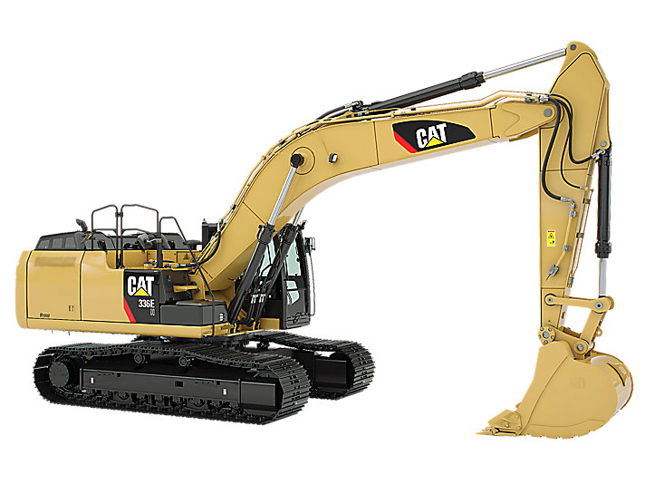
Excavator

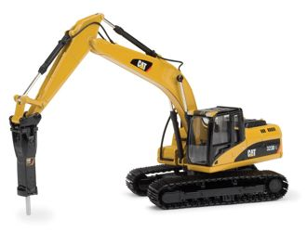
Rock hammer

